Assessment Differentiation System Help Manual

Step 1- My Profile:
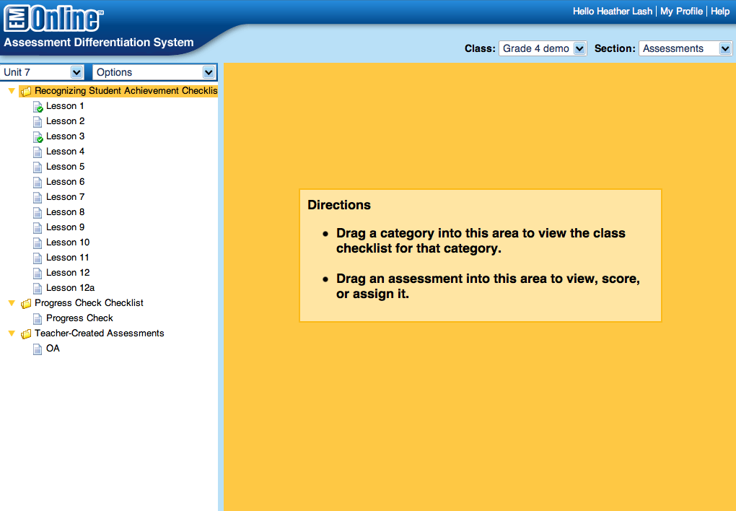
Click here to adjust settings

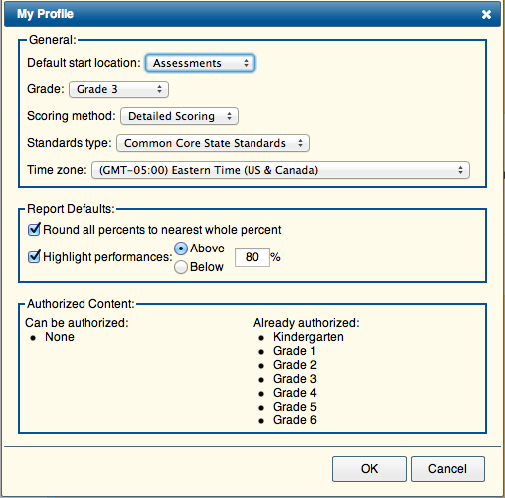Change the following:
Grade: to your level
Scoring method: detailed (for 4 pt rubric)
Check Highlight performances change % higher

Section: Assessments

This area of the system is used to score all assessments built within the program (daily Recognizing Student Achievement; Progress Check lessons; Mid Year; End of Year; and Teacher Created (both online and paper pencil)).

You can login to the system from a mobile device (i-Pad, smart phone, or tablet) to score the assessments. It will appear different from the slides below. These are for a computer desktop.

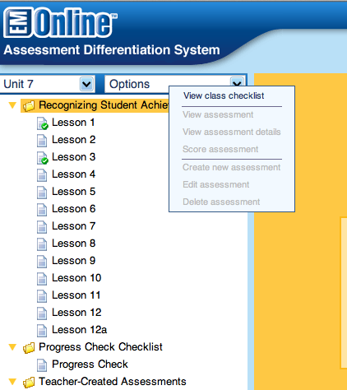
Pick your unit.

Click options and view class checklist.

You must have Recognizing Student Achievement highlighted yellow for this to work easily.

It will take a few moments to load your student and assessment data. If you have entered data on a mobile device the data will automatically appear in the checklist. If using the checklist to enter your data here are some helpful tips.
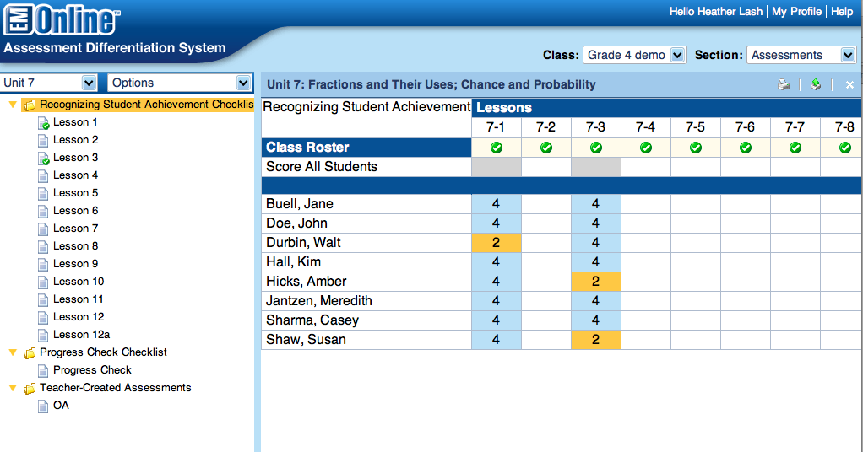
- Tap in the box titled “score all students” for the lesson you are scoring. This will default all students to a 4. If you tap again, it will drop to a 3 and so on.
- Next, you can change an individual student score by click the box for the lesson next to their name.
- If you would like to type comments, click the green checkmark at the top. This also shows which common core standards you are assessing.
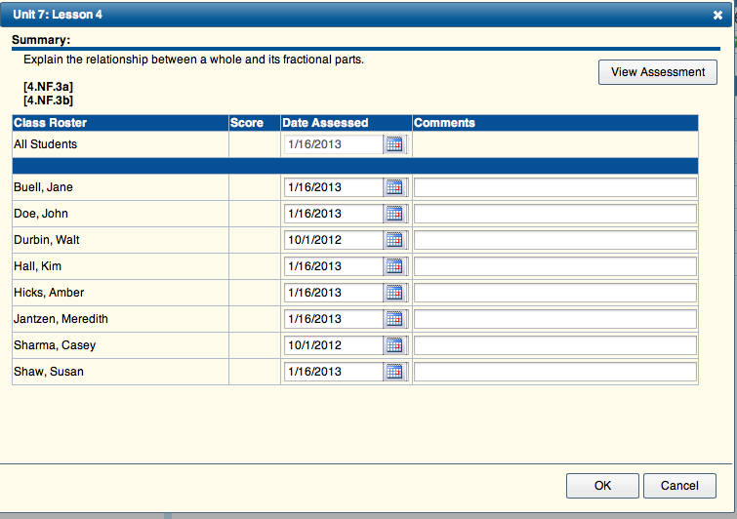

- Class and Individual Checklists, with data and comments filled in, can be printed by clicking on the print icon in the upper right.
- Finally all data can be exported to an excel file by clicking on the green arrow in the upper right corner.

When scoring the Progress Check (unit assessments), a helpful suggestion is to mark all questions to a level 4 first then change individual students as needed. Since teachers typically do not grade the unit assessments on a 4 point rubric, you may want to think of this as follows for the Progress Check ONLY:
4 – correct
3 – Conceptual understanding, but minor error
2 – wrong

Section – Reports

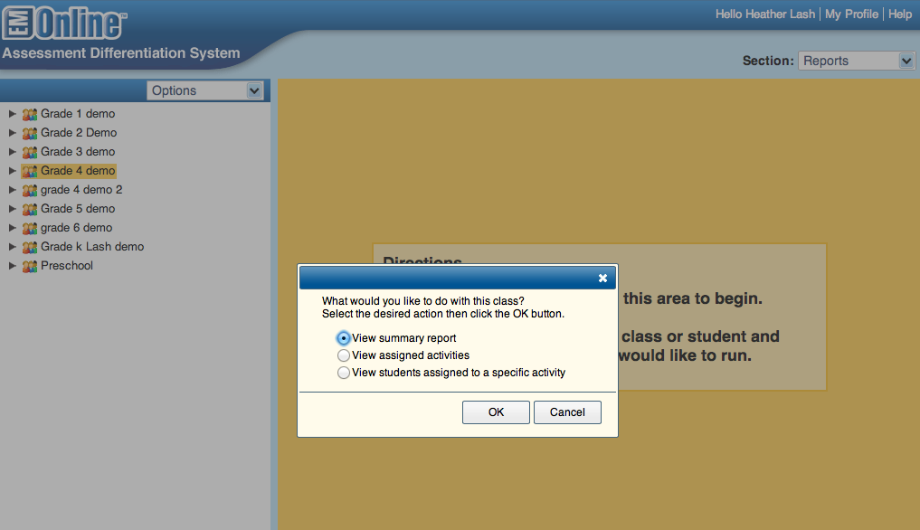

To enter the report area of the system, click on the section menu in the right corner and choose reports.

Click and drag your class to the right side of the screen. This opens the above window.

1. Summary report – summarizes the data according to Common Core or EM goals
2. Assigned Activities – Provides a class report detailing what interventions/enrichments have been assigned to students with date
3. Students assigned to activity – allows you to pick an activity and see which students need to do it.
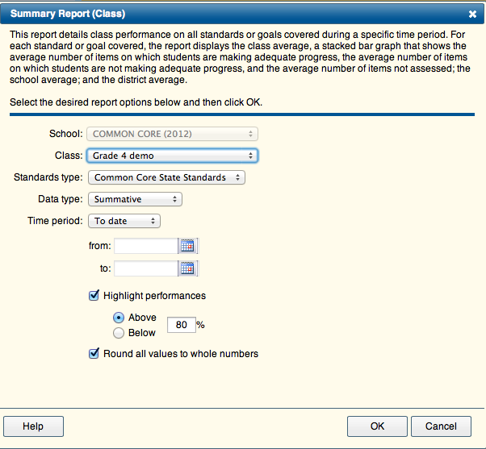

When you chose the summary report, you will be asked for the following info:

- common core or EM goals
- data type – all, formative, summative, teacher created, etc.
- date range – 9 week grading periods

The data will then be analyzed according to your specifications. If you highlight performances this will mark in green standards that are above the percent you indicate.

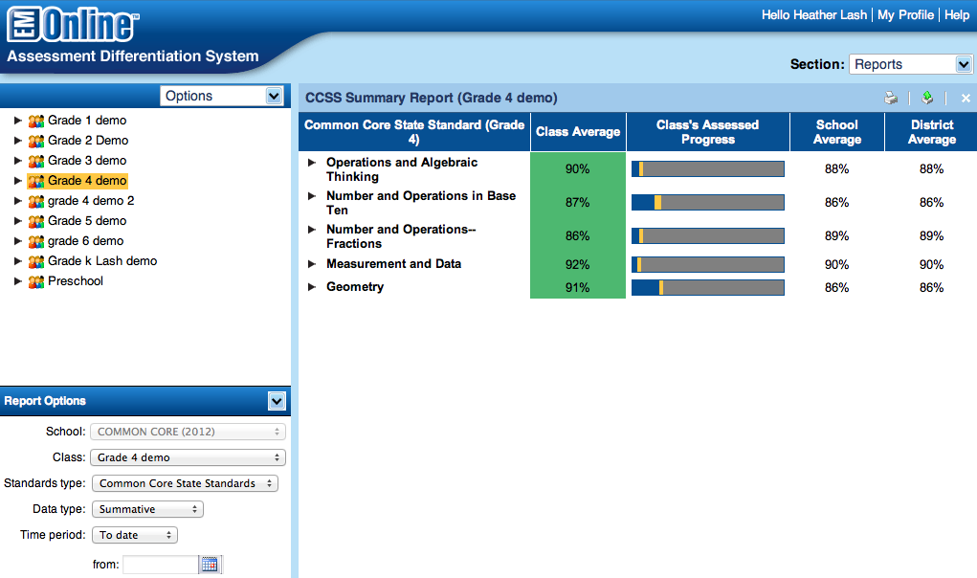

The reports pull all data placed into the system and organize by common core standards. Listed above are the grade 4 Domains from CCSS. The green shows which domains are performing above the 80% that I set as a target performance level. The bar graphs shows blue – adequate progress; yellow – not adequate; and gray yet to be assessed. You can compare you class averages to the school and district. When you click on a domain it will expand and show all of the standards with their data. To view student data, click on the magnify glass.

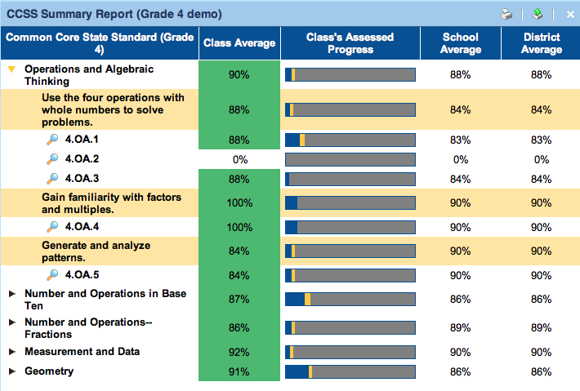

Here is an example of the student data:

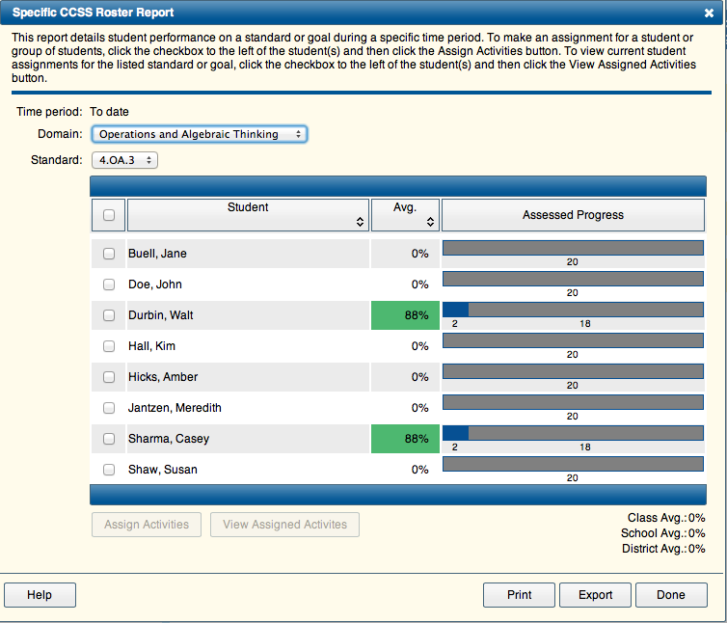

Click on the Avg. to sort them low to high.

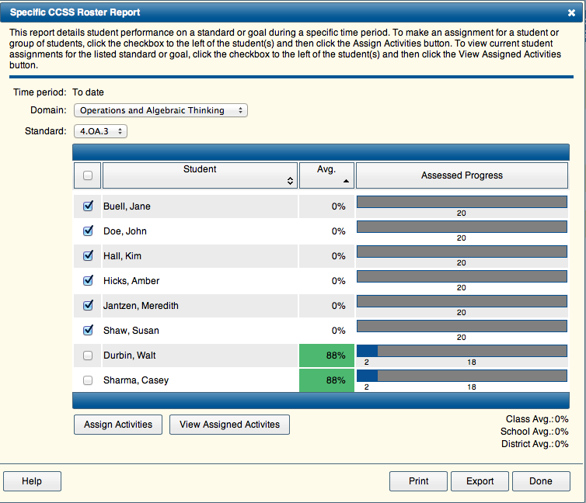

Check the names for the students you need to provide targeted intervention/enrichment. Click “Assign Activities.”

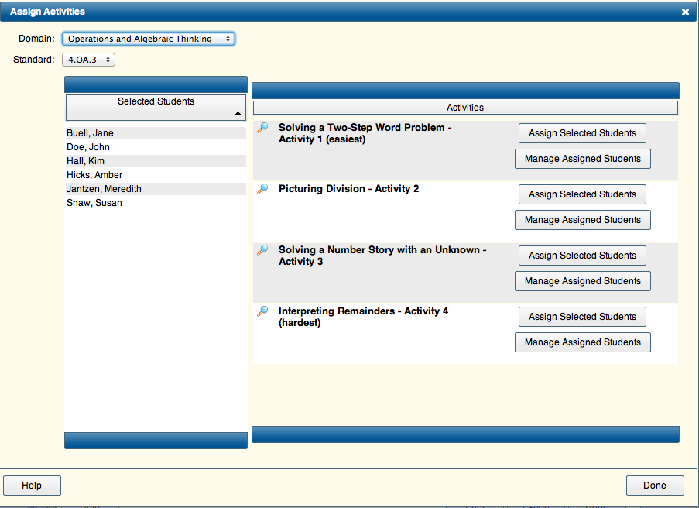
The activities are displayed easiest to hardest. You can preview an activity by clicking on the magnify glass next to the title. Once you find an activity you would like, click “Assign selected students.” The activities are NOT web based. You conduct these in small groups with your students during intervention time, math lab days, differentiation, parent volunteers, etc.

Previewing an activity …..

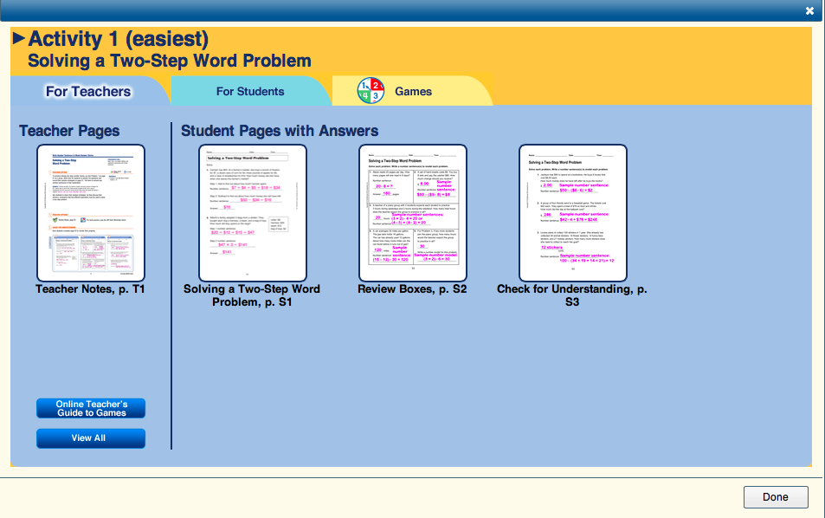

The activities are designed in a 3 part format. Part 1 is to be done in small group with an adult. There is typically a student page (S1) they do with you. Part 2 is review and practice. This contains Review Boxes that are similar to Math Boxes, but are practicing 1 targeted skill. Part 3 is an assessment to see if they now comprehend the concept/skill.

Some advice….

Click on the Teacher Page and print it. Do not print the student pages with answers.
Click on the “For Students” tab. Click the “View All” button and then print all student pages.

Organizing the Assigned Activities . . . .

Close the last several screen so you are back to the report page. Click on your class and drag to the right. This time choose, “View Assigned Activities.”

This opens a window with a running record for all activities you have assigned to students with date. These are great records for FIP.

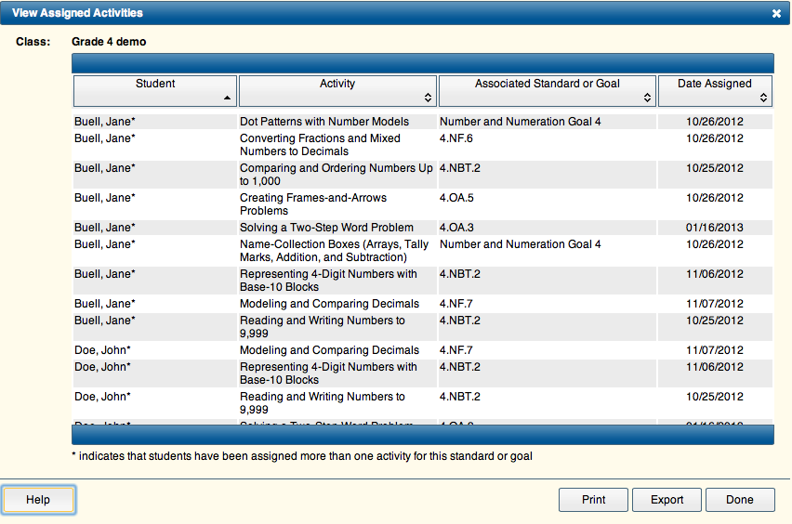
Section – Activities

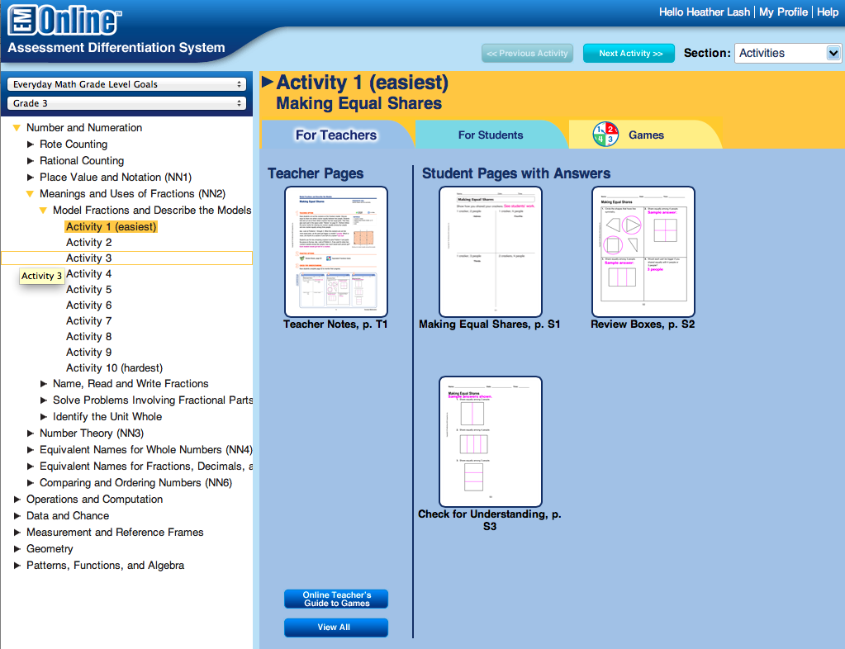

In the upper right corner, choose “Activities.”

This section allows you to review all of the leveled intervention/enrichment resources based on either common core or EM grade level goals. If you are looking for an intervention on a specific skill, it is easiest to search these by EM grade level goals as that gives more detail.

Section – Test Generator

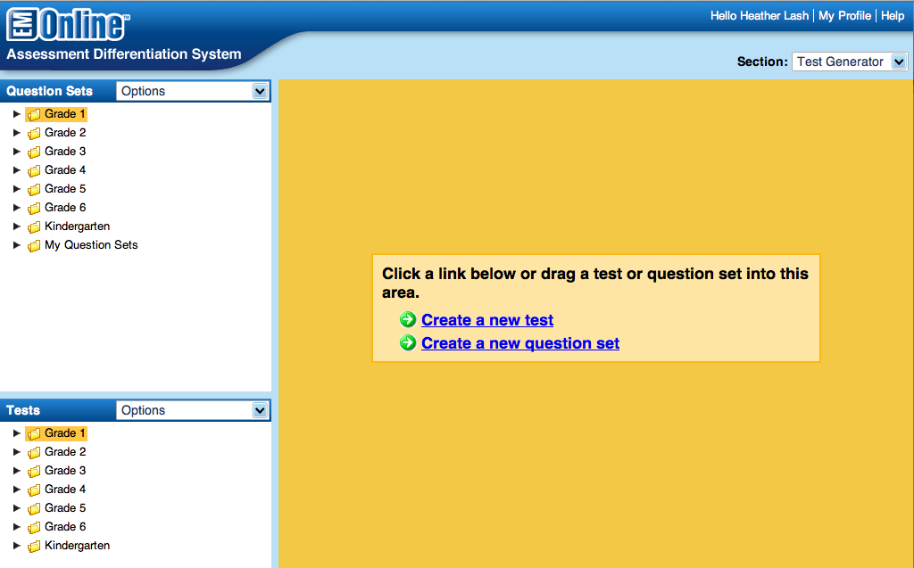

This section allows you to create pre-tests; study guides; quizzes; Common Core focused assessments, etc.

Click on “Create a new test.”

Option 1: Develop a pre-test or study guide:

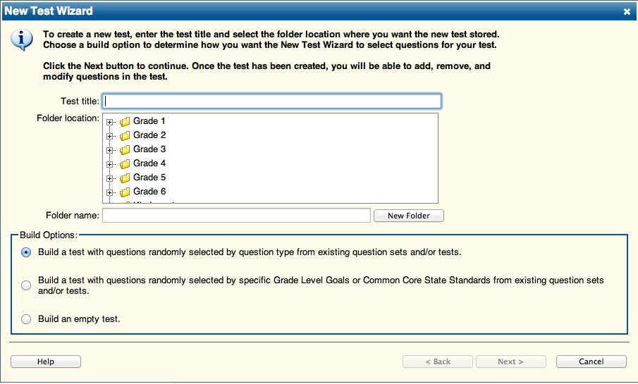

Create a title; click on the grade level words “Grade 3”; then click next.
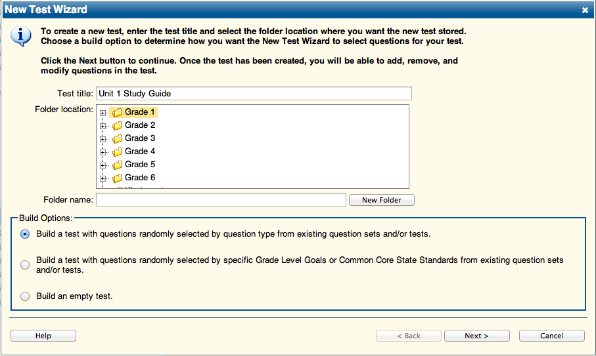
On the next screen click on the + signs until you see the list below:

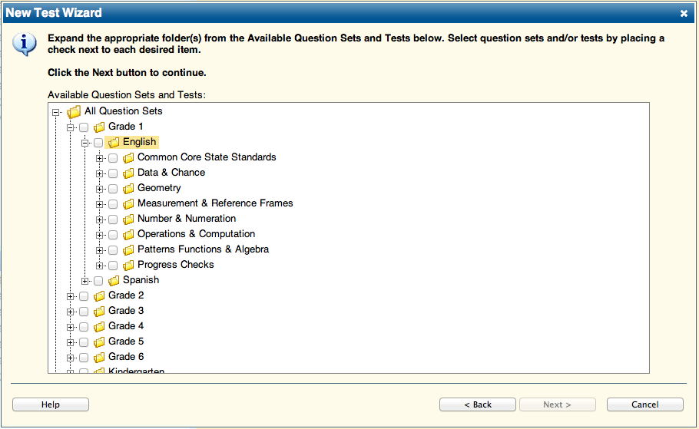

To create a study guide or pre-test, click the + next to Progress Checks.

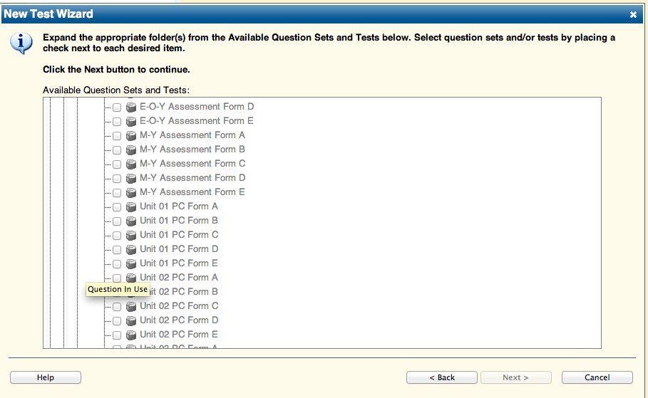

Find the unit you are working on, and click in the box next to one of the forms. Click next.

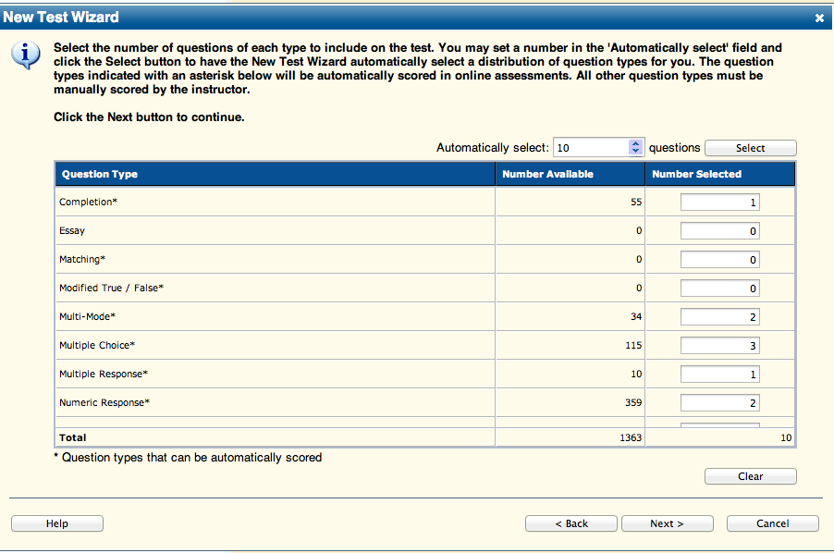

This screen shows the total number of questions available for the study guide. Select all of them by typing in the total number here and clicking on “select.”
Click next.

On the next screen, click finish and the program will create your assessment. It is automatically saved here.

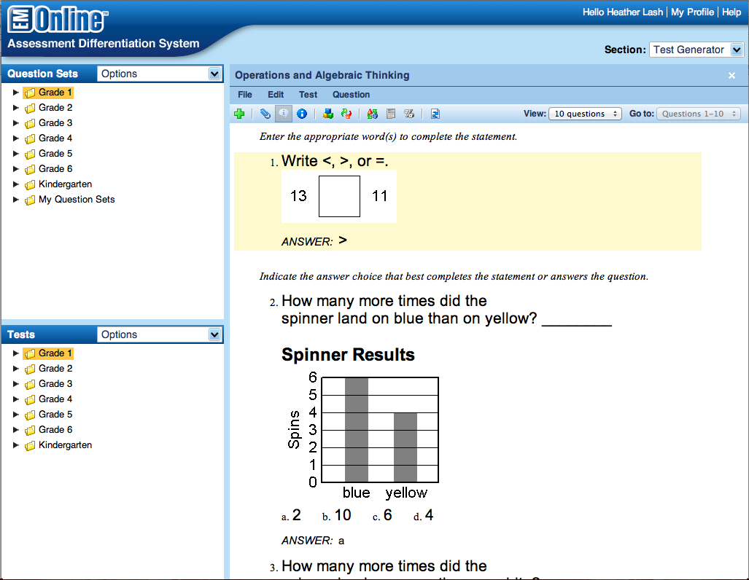

You can print off the assessment from the file menu. You want to choose single version. Be sure to uncheck the top option on this screen.
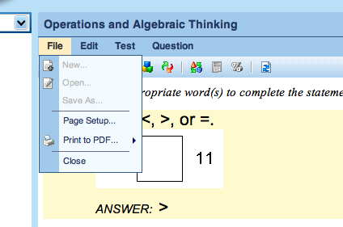

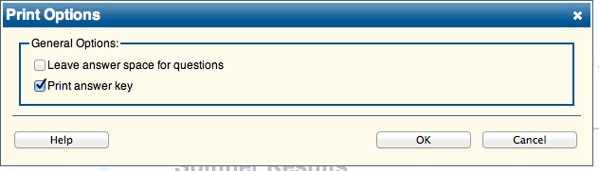
The program shows only 10 questions at a time. You can change that by clicking in the upper right corner the following box.
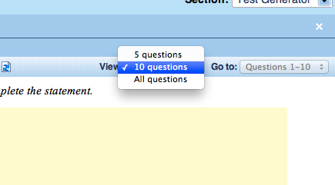

You can add additional questions to an assessment you have created by doing the following steps.

- Click on the white X in the upper right corner.
- Remember it is saved in “My Tests” in the left lower window.
- Click on your grade level + sign in the Question Sets.
- This reveals several options.
- Choose either a common core standard or an EM goal to look at.
- Drag it to the right side.
- This opens all available questions for that topic.
- Find a question you would like to add to your assessment.
- Drag it to the test here for example.

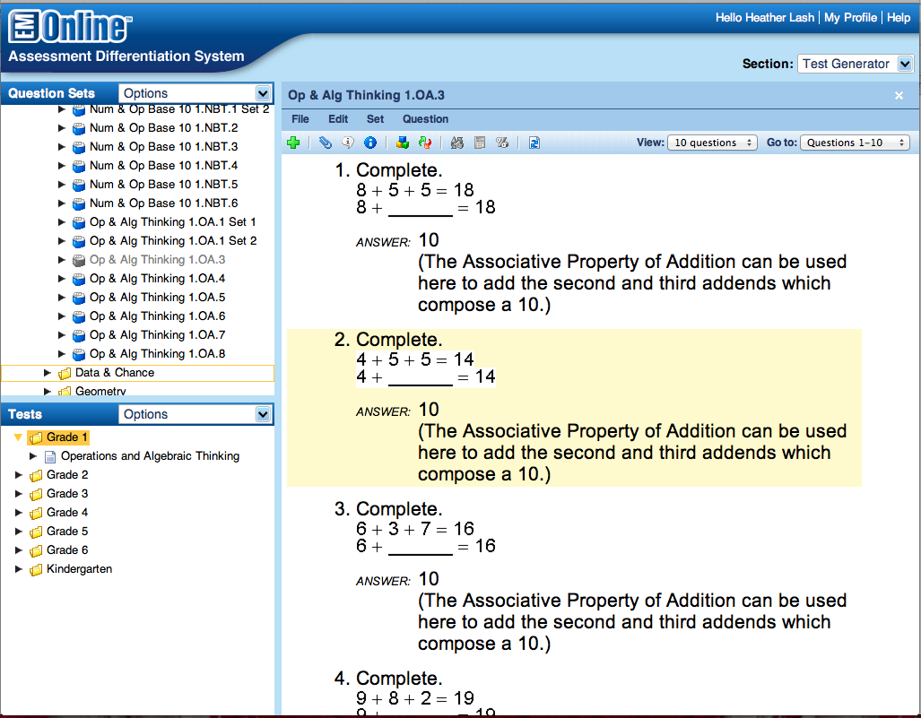

To create a Common Core Assessment:

- Click on “Test Generator.”
- Create a new test.
- Next, title the assessment in the wizard.
- Click the name of the grade level so it is highlighted in yellow.
- Check the middle “Build” option. See below:
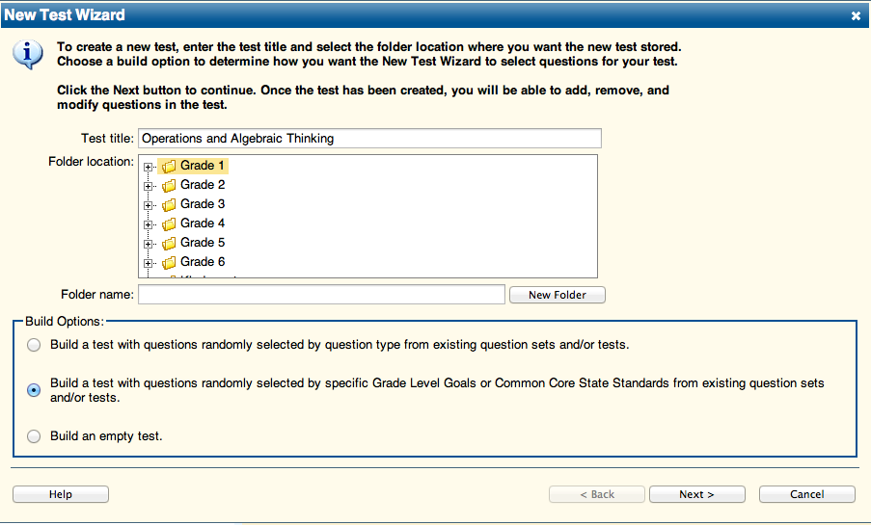

On the next screen click the + signs until you see the screen below. Then check the box next to “Common Core State Standards.”

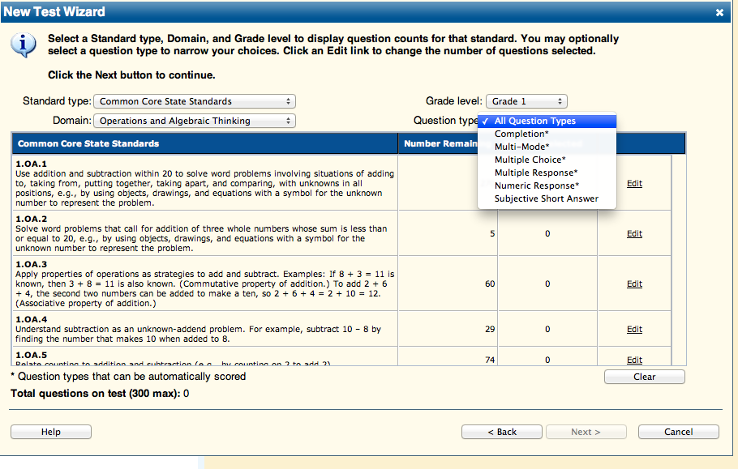

This screen appears. Select your grade level, common core, and domain.
You can then edit the number of questions for each standard. Be sure to click update after you change each number of items.

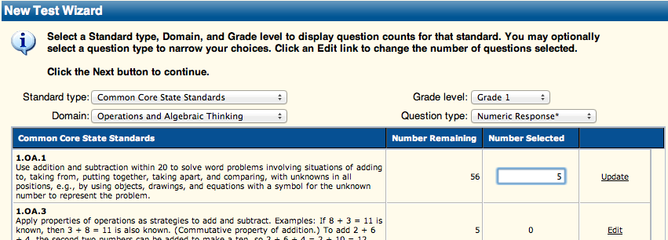

You can create an assessment to be given online by choosing Question type. The types of questions that can be taken online have a * next to them.

Once you have selected how many of each question you would like for your assessment. Click, “next.” Then click finish on the next screen.

To Create An Online Assessment:

- Complete the steps listed above to create a test/quiz that contains only question types marked with an *.
- Next, go to Section: Assessments (upper right corner)
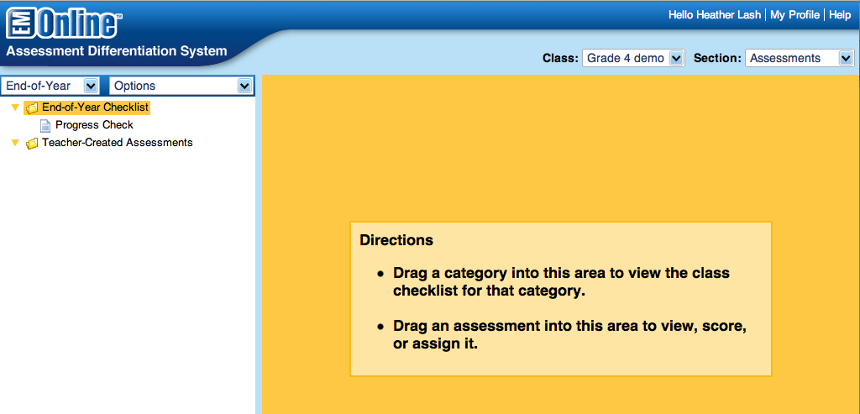

- Click on teacher created assessments, and drag that to the right side of the screen.
- 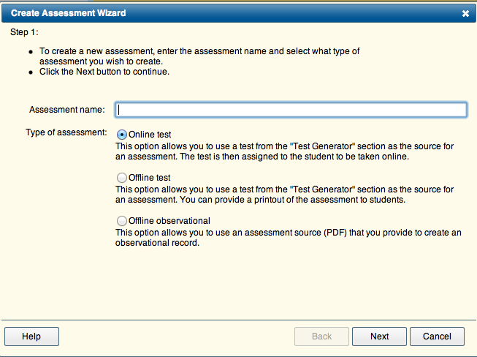
- Title the assessment and choose to make it an online test. Click next.
- Open your grade level folder and find the assessment.
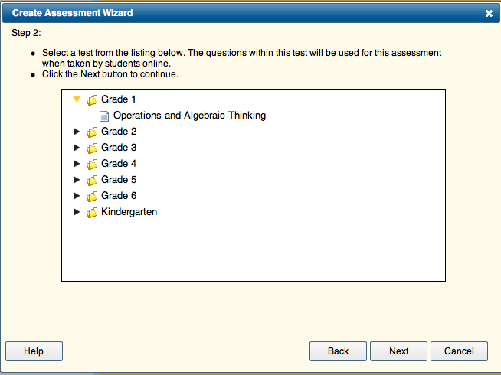
- Next, you may change various settings. See below:
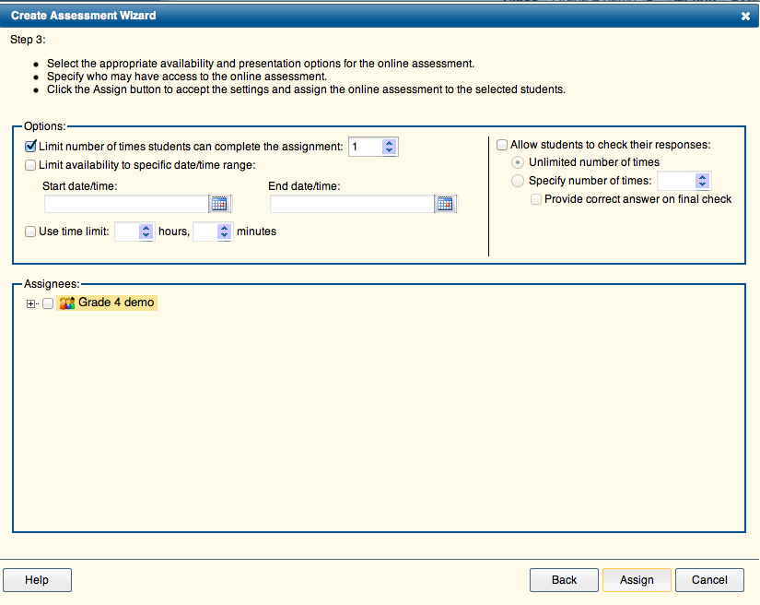

- Click the box next to the name of your class. Then, click assign.
- The assignment will now appear on the student’s screen when the login. The scores will appear here after they complete it.

Creating a Checklist to Monitor Intervention Data:

- Section: Assessments
- Choose the unit for the interventions.
- Drag the Teacher Created Assessments to the right side.
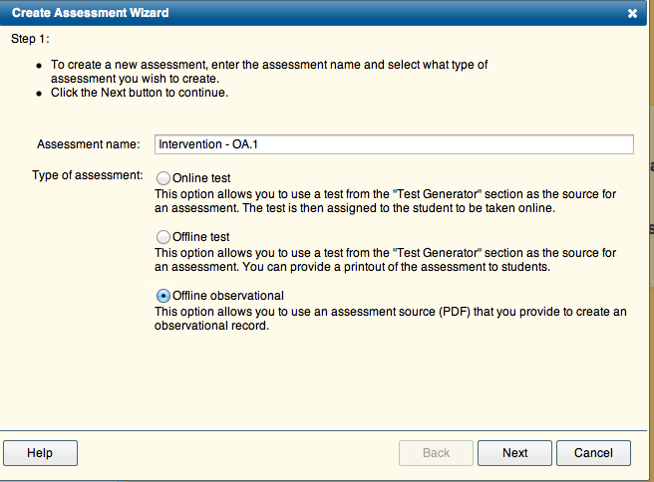

- Create a title.
- Choose “Offline observational.”

- You will then be asked to identify the common core standards that the intervention aligns with.
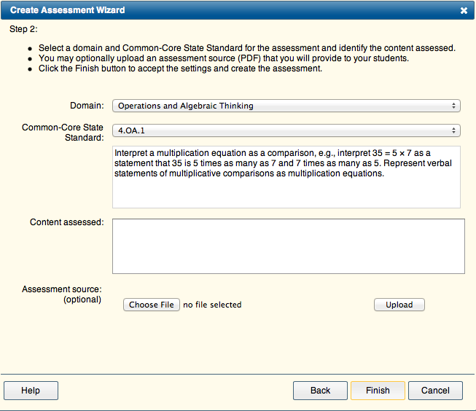

You may add detail as to the content assessed; intervention task used, etc. You may also upload a pdf copy of the assessment that was given. Click Finish when done.

To enter student scores for this intervention:

- Open the Teacher Created Assessments on the left.
- Drag the intervention to the right.
- This will open the checklist to score just like the daily assessments.
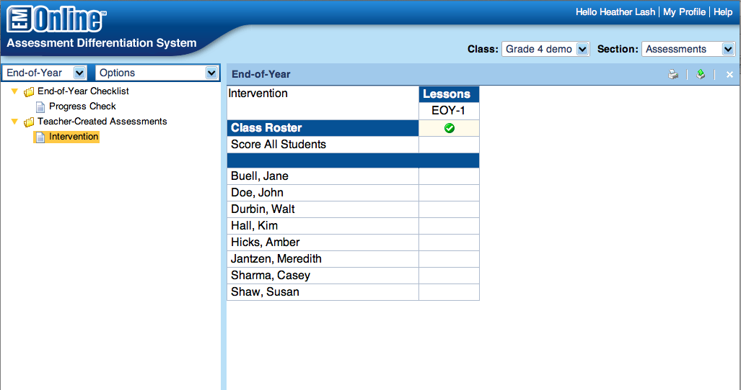

The data will then be compiled in the report section.

